Mole Valley Orienteering Club
(affiliated to the British Orienteering Federation)

NORBURY PARK, nr Leatherhead
Colour Coded Event
Monday 5th May 2003

Organiser: Michael White 01306 888886

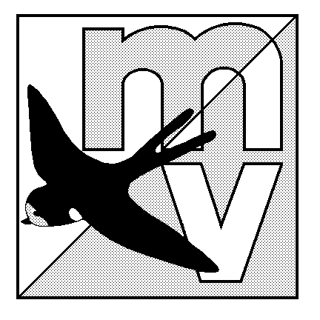

The Event will be using Sport-Ident electronic punching.

Directions: Young Street Car Park by the River Mole, off the A246 just West of its junction with the A24 near Leatherhead. Junction 9 of the M25 is just 3 miles away.
The car park is at Grid Ref : TQ163551.

Registration/Enquiries: This will be in the Car park. Registration 10.00 – 12.00.
Entry on the Day.

Courses: White, Yellow, Orange, Red, Light Green, Green, Blue, Brown. Planned by Jon Coles.

Fees: £3.50 & £1.50 Juniors. Sport Ident card hire £1.00 per card. Parking fee of £1.00 per vehicle.

Starts: 10.30 – 12.30.

Terrain: Undulating runnable mixed woodland, coppice, plantation and chalk grassland high above the River Mole, all at its best in early May. Courses have been planned to avoid the scarp slope down to the river.

Information and Results: Will be available on the Mole Valley web page (http://www.mvoc.org/) and by post.

Facilities: Squash will be available in the car park. There are NO toilets available, please go before you arrive.

Dogs: Welcome.

Controller: Gordon Parker (SLOW).

COMPETITORS PARTICIPATE AT THIS EVENT AT THEIR OWN RISK.

